Chapter 1
1. What are statements that define and qualify what the program needs to do?
Program requirements: statements that define and qualify what the program needs to do.
2. What are statements that constrain the ways in which the software can be designed and implemented?
Design constraints: statements that constrain the ways in which the software can be designed and implemented
3. Which type of requirements statement defines what the program needs to do?
Functional requirements: What a program needs to do
4. What requirements qualify as functional requirements? Specify in what manner they need to be achieved
Nonfunctional requirements: the manner in which the functional requirements need to be achieved.
5. Which decisions are those taken by the software engineer about the best ways (processes, techniques, and technologies) to achieve the requirements?
Programming language? Algorithms?
6. What type of testing refers to testing done by the clients (or somebody on their behalf) to make sure the program runs as specified?
Acceptance testing
7. What is GUI? What is CLI?
8. List three of the typical kinds of nonfunctional requirements?
Performance requirements: The program needs to finish most or all inputs within a certain amount of time.
Real-time requirements: When a program need to perform in real-time, which means it must complete the processing within a given amount of time, performance is an issue. The variability of the running time is also a big issue. We may need to choose an algorithm with a less than average performance, if it has a better worst case performance.
Modifiability requirements: If a program is going to be used for a long time, we need to make it easy to maintain and modify.
Chapter 2
1. Define the depth versus the breadth issue in software complexity
The breadth issue addresses the sheer numbers (các con số tuyệt đối) involving the following:
- Major functions
- Features within each functional area
- Interfaces of other external systems
- Simultaneous users
- Types of data and data structures.
The depth issue addresses the linkage and the relationships among items. The linkage may either be through the sharing of data or through the transfer of control, or both. These relationships may be hierarchical, sequential, loop, recursive, or some other form.
2. Describe a way to simplify a complex problem
Problem and design decomposition
How we divide a large complex problem and its solution into smaller parts?
1. We first need to simplify the large complex problem by addressing the problem in smaller segments.
2. After we have successfully completed that process, our next step is to decide whether we should design and decompose the software system solution along the dividing lines of the problem segments.
3. List technical and non-technical issues in developing large systems
Technical:
Problem and solution simplification
Technology and tools choices
Process and Methodology
Non-Technical:
Project effort estimation and scheduling
Assignments and communications
4. What is the maximum number of communication paths for a team of 20 people?
5. List four factors that should be considered in deciding how many post-release people will be needed?
Number of expected users and customers
Number and type of known problems that existed at release time
Projected number of problems that will be discovered by users
Amount of user training
Amount of support personnel training
Number of development personnel committed to support the system
Expected number of problem-fix releases and future functional releases.
Chapter 3. Engineering of software
1.List key reasons that have caused both software project successes and failures
Success:
User involvement
Executive management support
Clear requirement statements
Proper planning
Failure:
Lack of user input
Incomplete requirements
Changing requirements
2. From the definition of software engineering, list three areas that software engineering must touch upon
Technical and business processes
Specific methodologies and techniques
Product characterization and metrics for measurements
People skills and team work
Project coordination and management
3. List two of the three strategies cited by the 2004 U.S. General Accounting Office report as key to ensuring delivery of successful software.
Software developers and acquirers at firms that GAO visited use three fundamental management strategies to ensure the delivery of high-quality products on time and within budget: working in an evolutionary environment, following disciplined development processes, and collecting and analyzing meaningful metrics to measure progress. When these strategies are used together, leading firms are better equipped to improve their software development processes on a continuous basis. An evolutionary approach sets up a more manageable environment—one in which expectations are realistic and developers are permitted to make incremental improvements. The customer benefits because the initial product is available sooner and at a lower, more predictable cost. This avoids the pressure to incorporate all the desired capabilities into a single product right away. Within an evolutionary environment, there are four phases that are common to software development: setting requirements, establishing a stable design, writing code, and testing. At the end of each of these phases, developers must demonstrate that they have acquired the right knowledge before proceeding to the next development phase. To provide evidence that the right knowledge was captured, leading developers emphasize the use of meaningful metrics, which helps developers, managers, and acquirers to measure progress. These metrics focus on cost, schedule, the size of a project, performance requirements, testing, defects, and quality.
4. When and Where was the term software engineering first introduced?
Nato conference 1968.
5. What are the eight principles for software engineering code of ethics recommended by the IEEE-CS/ACM Version 5.2 joint task force report?
  - Software engineers shall act consistently with the public interest
  - Software engineers shall act in a manner that is in the best interest of their client and employer, consistent with the public interest
  - Software engineers shall ensure that their products and related modifications meet the highest professional standards possible
  - Software engineers shall maintain integrity and independence in their professional judgment
  - Software engineering managers and leaders shall subscribe to and promote an ethical approach to the management of software development and maintenance
  - Software engineers shall advance the integrity and reputation of the profession consistent with the public interest
  - Software engineers shall be fair to and supportive of their colleagues
  - Software engineers shall participate in lifelong learning regarding the practice of their profession and shall promote an ethical approach to the practice of the profession.
6. What is meant by the term principles of software engineering?
Principles are natural laws that have evolved through numerous years of past experience. Because software engineering is still young and still developing, the existing principles will continue to be modified and new ones added.
7. Can a software engineer become a certified Professional Engineer (PE)? Explain
- Software is a serious business
  - Reached $180 billion in 2000
  - It is ubiquitous across multiple industries
- Software is a commodity of increasing “Value”
- The business of software has graduated from a “garage” operation to an “enterprise” profession
- We need to treat software engineering as an engineering profession

8. List Davis’s Early 15 principles
Make quality number 1
High quality software is possible
Give products to customers early
Determine the problem before writing the requirements
Evaluate design alternatives
Use an appropriate process model
Use different languages for different phases
Minimize intellectual distances
Put techniques before tools
Get it right before you make it faster
Inspect code
Good management is more important than good technology
People are the key to success
Follow with care
Take responsibility
Chapter 4. Software Process Models.
1. Discuss one advantage and one disadvantage of the waterfall process

Advantages of Waterfall Iterative Model
1) Waterfall model is simple to implement and also the amount of resources required for it are minimal.
2) In this model, output is generated after each stage (as seen before), therefore it has high visibility. The client and project manager gets a feel that there is considerable progress. Here it is important to note that in any project psychological factors also play an important role.
3) Project management, both at internal level and client's level, is easy again because of visible outputs after each phase. Deadlines can be set for the completion of each phase and evaluation can be done from time to time, to check if project is going as per milestones.
4) This methodology is significantly better than the haphazard approach to develop software. It provides a template into which methods of analysis, design, coding, testing and maintenance can be placed.
5) This methodology is preferred in projects where quality is more important as compared to schedule or cost.

Disadvantages of Waterfall Iterative Model of SDLC
1) Real projects rarely follow the sequential flow and iterations in this model are handled indirectly. These changes can cause confusion as the project proceeds.
2) It is often difficult to get customer requirements explicitly. Thus specifications can't be freezed. If that case arises baseline approach is followed, wherein output of one phase is carried forward to next phase. For example, even if SRS is not well defined and requirements can't be freezed, still design starts. Now if any changes are made in SRS then formal procedure is followed to put those changes in baseline document.
3) In this model we freeze software and hardware. But as technology changes at a rapid pace,such freezing is not advisable especially in long-term projects.
4) This method is especially bad in case client is not IT-literate as getting specifications from such a person is tough.
5) Even a small change in any previous stage can cause big problem for subsequent phases as all phases are dependent on each-other.
6) Going back a phase or two can be a costly affair.

Projects where Waterfall Method is suitable for SDLC:-
1) In development of database-related software, eg commercial projects.
2) In development of E-commerce website or portal.
3) In Development of network protocol software.
2. What is the goal of a software process model?
Provide guidance for a systematic coordination and controlling of the tasks and of the personnel who performs the tasks
3.What are the four quadrants in a spiral model? Trace the requirements set of activities through each quadrant.
Identify the objectives, alternatives, or constraints for each cycle of the spiral.
Evaluate the alternatives relative to the objectives and constraints. In performing this step, many of the risks are identified and evaluated.
Depending on the amount of and type of identidied risks, develop a prototype, more detailed evaluation, an evolutionary development, or some other step to further reduce risk of achieving the identified objective. On the other hand, if the risk is substantially reduced, the next step may just be a task such as requirements, design, or code.
Validate the achievement of the objective and plan for the next cycle.
4. What are the entry and exit criteria to a process?
5. What motivated software engineers to move from the waterfall model to the incremental or spiral model?
6. What are the major concepts that drove the Rational Unified Process framework?
7. What are the four phases of the Rational Unified Process?
Inception, Elaboration, Construction, Transition.

8. List all of the key processes addressed by SEI’s CMM model. Which ones are required for maturity level 2?

- Software Engineering Institute (SEI) proposed a Capability Maturity Model (CMM) to help software organizations assess their maturity and provide guidance in software development.
  - Initial : there is no process and any success is by luck or with a special person.
  - Repeatable: has mastered 6 processes and can repeat its success with these 6 processes: 1) requirements mgmt, 2)project tracking, 3)quality assurance, 4)project planning, 5)subcontract mgmt, and 6)configuration management
  - Defined: has mastered 7 more processes and is competent at software construction: 1) organization process, 2) training program, 3) product engineering, 4) peer review, 5) organization process definition, 6) integrated soft. mgmt, and 7) inter-group coordination
  - Managed: has introduced 2 more processes that deal with quantitative measurement and quality: 1) quantitative process management and 2) quality mgmt
  - Optimizing: reaching this highest level requires the mastering of continuous improvement with 3 more processes: 1)defect prevention, 2) technology change management, 3) process change management

9. How many process areas, in total, are included in SEI’s Software CMMI? List those that fall into the engineering category and the support category
In 2001, CMM was upgraded to CMMI (CMM Integrated).
- There are 25 processes covering 4 major categories :
  - Process Management (has 5 processes):
    - Organization process focus
    - Organizational process definition
    - Organizational training
    - Organizational process performance
    - Organizational innovation and deployment
  - Project Management (has 8 processes):
    - Project planning
    - Project monitoring and control
    - Supplier agreement management
    - Integrated project management
    - Risk management
    - Integrated teaming
    - Integrated supplier management
    - Quantitative project management
- Engineering (has 6 processes)
  - Requirements development
  - Requirements management
  - Technical solution
  - Product integration
  - Verification
  - Validation
- Support (has 6 processes)
  - Configuration management
  - Process and product quality assurance
  - Measurement and analysis
  - Organizational environment for integration
  - Decision analysis and resolution
  - Causal analysis and resolution

Chapter 5.
1. List problems with trational processes
Lengthy development time
Inability to cope with changes in requirements
Assumes requirements are understood at beginning of project
Relies on heroic development effort
Complex methodology
Waste/duplication of effort
2. List the four core values of XP
Communication (between team and with customers)
Simplicity (in design and code)
Feedback (at many levels)
Courage (to make and implement difficult decision)
3. List five XP practices
- Planning
  - Determine features to be included in next release
  - Business priorities and technical estimates
- Short releases
  - Get a working system quickly
  - Release new versions in short cycles (2 to 4 weeks)
  - Base new detail plans on customer feedback
- Metaphor
  - Use a metaphor instead of an architecture
- Simple design
  - Eliminate unnecessary complexity as soon as possible
  - Design can be changed in later versions
- Test-driven development
  - Continuous and automated
  - Write tests before writing code
- Design improvement (Refactoring)
  - Remove duplication, improve communication, and simplify or add needed flexibility
- Pair programming
  - Two programmers working at same machine
- Collective ownership
  - Anyone can change any code at any time
- Continuous integration
  - Integrate and test every time a task is completed (many times a day)
- Sustainable pace
  - 40 hours a week reasonable
  - Never overtime two consecutive weeks
- On-site customer
  - Include real customer on the team
- Coding standards
  - Everyone needs to use the same rules
4. What factors does the Crystal family consider when choosing a methodology?
  - Size (number of developers)
  - Criticality: Loss that a malfunction would cause
    - Life
    - Essential money
    - Discretionary money
    - Customer comfort
  - Priority (time pressure)

5. Explain some of the characteristics of Agile methodologies
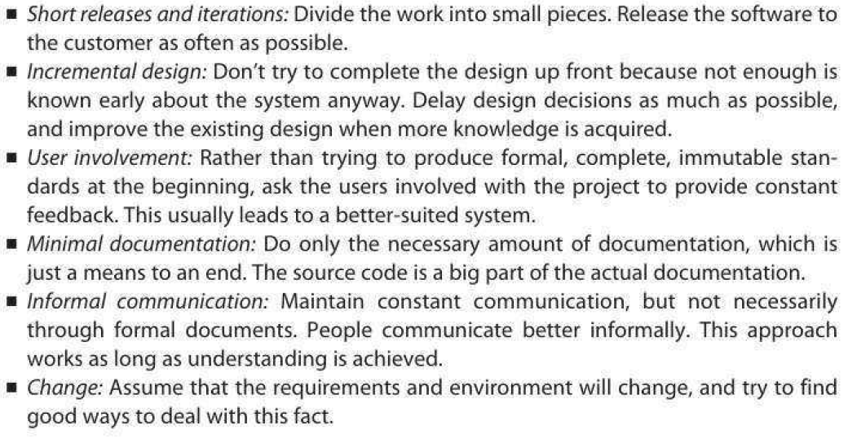
6. Explain the main aspects that open source development shares with Agile methods
- Similarities
  - Small releases
  - Informal communications
  - Customer availability
  - Continuous integration
  - Shared Vision
7. Compare and contrast Agile and traditional methods
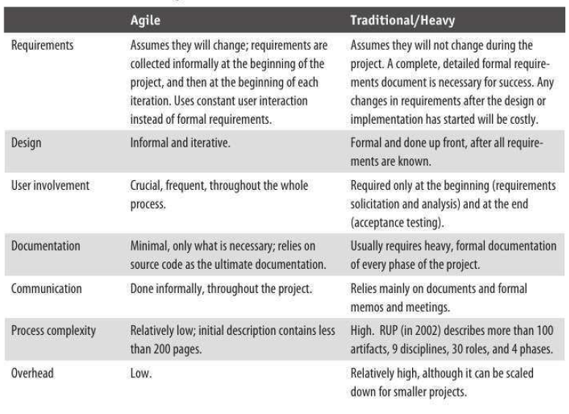
8. Agile methods prefer working programs over comprehensive documentation. (True/False)
9. Agile methods prefer rigid processes over adapting to the people. (True/False)
10. What is test-driven programming, and which Agile process advocates it?
Chapter 6.
1. List and describe at a high level the steps involved in software requirements engineering process
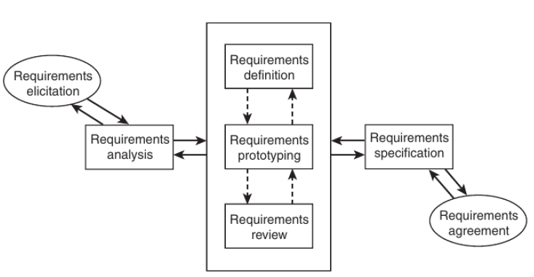
2. What are the three main items that must be planned prior to conducting requirements engineering?
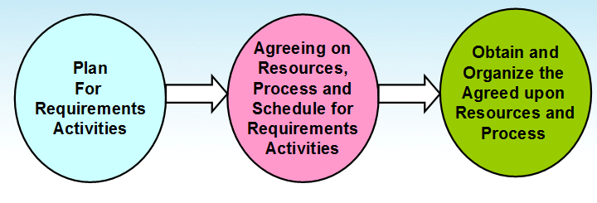
3. What are the six main dimensions of requirements that you need to address when collecting requirements?
6-Dimensions of Detailed Requirements Elicitation
Requirements
Individual Functionality (1)
Business Workflow (2)
Data and Data formats (3)
User Interfaces (5)
Existing & Systems Interfaces (6)
Other Constraints: Performance,
Reliability, etc. (4)
4. List four items that are included in the description of high-level business profile.
5. List and “describe three items” that you will need to consider when prioritizing requirements.
- Current user/customer demands or needs
- Competition and current market condition
- Anticipated future and new customer needs
- Sales advantages
- Critical problems in existing product
6. What is the viewpoint-oriented requirements definition method used for?
VORD methodology is divided into four steps:
- View Oriented Requirements Definition (VORD) is based on the concept that requirements are viewed differently by different people:

  - Identify stakeholders and their viewpoints of the requirements
  - Categorize the viewpoints of requirements and eliminating any duplication
  - Refine the identified viewpoints of requirements
  - Map the viewpoints of requirements to the system and the services that the system must provide
7. Consider the situation where you have the following four requirements for an employee information system:
....
8. Explain in an ER diagram the relationship between programmers and modules where a programmer may write several modules and each module may also be written by several programmers.
9. What are the four types of requirements traceability?
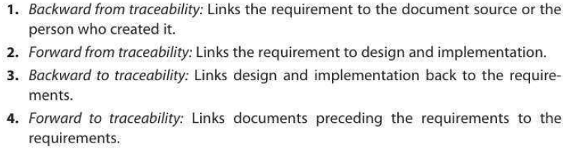
Chapter 7.
1. Explain the role of requirements in architectural design. Explain the role of requirements in detail design.
2. What is Software architecture? List key uses of architecture descriptions.
Software architecture:
- Definition: Software architecture is the structure or structures which comprise elements, their externally visible properties, and relationships among them
  - Elements: only interested in external properties needed for relationship specification
  - Details on how the properties are supported is not important for architecture
  - The definition does not say anything about whether an architecture is good or not – analysis needed for that
- An architecture describes the different structures of the system

Key Uses:
Understanding and communication
Reuse
Construction and evolution
Analysis
3. What is the structure and characteristic of the architectural style: Pipe and filter. Give an example
- Well suited for systems that mainly do data transformations
- A system using this style uses a network of transforms to achieve the desired result
- Has one component type – filter
- Has one connector type – pipe
- A filter does some transformation and passes data to other filters through pipes
- A filter is independent; need not know the id of filters sending/receiving data
- Filters can be asynchronous and are producers or consumers of data
- A pipe is unidirectional channel which moves streams of data from one filter to another
- A pipe is a 2-way connector
- Filters have to perform buffering, and synchronization between filters
- Filters should work without knowing the identify of producers/consumers
- A pipe must connect the output port of one filter to input port of another
- Filters may have independent thread of control
4. What is the structure and characteristic of the architectural style: Client-Server.
5. What is the structure and characteristic of the architectural style: Shared-Data.
6. What is the structure and characteristic of the architectural style: Three tier Style.
7. List and describe steps in database design.
8. List and describe 3 types of UML diagrams in OO Analysis and Design.
9. List issues with user interface design
Chapter 8.
1. Describe two fundamental characteristics of a good design besides the design should match requirements.
- Besides the obvious - - - design should match the requirements - - - there are two fundamental characteristics:
  - Consistency across design:
    - Common UI
      - looks
      - Logical flow
    - Common error processing
    - Common reports
    - Common system interfaces
    - Common help
    - All design carried to the same depth level
  - Completeness of the design
    - All requirements are accounted for
    - All parts of the design are carried to their completion, to the same depth level
2. Describe Halstead Volume metric. Trình bày cách tính độ đo dung lượng (Volume) của Halstread để phân tích độ phức tạp của chương trình nguồn.
3. Trình bày cách tính độ phức tạp module Cyclomatic (Cyclomatic Complexity) của McCabe.
4. Trình bày cách tính độ phức tạp liên module của Henry-Kafura.
5. Trình bày các cấp độ ghép nối (coupling) giữa các module.
6. Trình bày các cấp độ kết dính (cohension) guiwuas các phần tử trong một module.
7. Trình bày cách tính độ đo kết dính chức năng yếu và mạnh (weak functional cohesion and strong functional cohesion) của Bieman và Ott
8. Trình bày 8 quy tắc thiết kế giao diện người dùng của Shneiderman và Plaisant.
Chapter 9.
1. Cho biết các lỗi lập trình thường gặp
- Memory Leaks
  - Memory that is not freed when no longer needed
- Freeing an already freed resource
- NULL dereferencing
  - Trying to access the contents of a location that points to NULL
- Lack of unique addresses
  - Caused by aliasing
- Array index out of bound
- Arithmetic exceptions
- Off by one
  - Starting at 1 when we should start at 0
- Enumerated data types
  - Cause overflow and underflow
- Illegal use of & instead of &&
- String handling errors
- Buffer overflow
2. Liệt kê 10 thông lệ lập trình (programming practices)
- Control constructs: Use only a few structured constructs (rather than using a large number of constructs)
- Goto: Use them sparingly, and only when the alternatives are worse
- Information hiding: Use information hiding
- Use-defined types: use these to make the programs easier to read
- Nesting: Avoid heavy nesting of if-then-else
  - Easier to do if conditions are disjoint
- Module size: Should not be too large – generally means low cohesion
- Module interface: make it simple
- Robustness: Handle exceptional situations
- Side effects: Avoid them, document when exist
  - Use of global variables, etc.
- Switch case with default
- Empty catch block: always have some default action rather than empty
- Empty if, while: bad practice
- Read return: should be checked for robustness
- Return from finally: should not return from finally
- Correlated parameters: Should check for compatibility
  - Parameter needs to match the operation

3. Liệt kê các chuẩn lập trình Java
4. Vẽ và mô tả biểu đồ biểu diễn tiến trình lập trình tăng dần (incremental coding process)
5. Vẽ và mô tả biểu đồ biểu diễn tiến trình lập trình hướng kiểm thử (test driven development)
6. Trình bày các đặc điểm của lập trình đôi (Pair Programming).
7. Liệt kê 10 mục cần kiểm tra khi thanh tra chương trình

Chapter 13.
1. Cho biết các giai đoạn và các mục tiêu của tiến trình quản lý dự án phần mềm.
2. Cho biết các bước của giai đoạn lập kế hoạch trong tiến trình quản lý dự án phần mềm.
3. Cho biết các công việc được thực hiện trong giai đoạn tổ chức trong tiến trình quản lý dự án phần mềm.
4. Trình bày chương trình khung để xây dựng cấu trúc phân rã công việc (Work breakdown Structure) trong việc ước lượng công sức hoàn thành dữ án.
Chapter 11.
1. Liệt kê 10 sản phẩm (artifacts) được quản lý cấu hình.
2. Cho biết vai trò của quản lý cấu hình và các chức năng cơ bản của quản lý cấu hình.
3. Cho biết mô hình lưu trữ và truy cập các thành phần (Parts Storage and Access Model) trong quản lý cấu hình và các tính năng chính của mô hình này.
Chapter 12.
1. Cho biết các công việc cần thực hiện trong hỗ trợ khắc phục khiếm khuyết phần mềm (defect support) và cho biết xu hướng thay đổi của số lượng khiếm khuyết theo thời gian sau khi chuyển giao phần mềm.
2. Trình bày hai đặc điểm của công việc hỗ trợ khách hàng (Customer Support)
- Software support is not free
  - Most charge an annual fee (e.g. 18% of product)
- Software support is not forever
  - Most product goes through a number of releases
  - Each product release is only supported for a limited number of years
  - Customers/users are moved from back-level software to the current release as soon as possible
    - Usually support no more than 2 back-levels of a software
3. Cho biết các công việc thực hiện trong giai đoạn trước khi kết thúc việc hỗ trợ phần mềm, hay còn gọi là giai đoạn mặt trời lặn (product sunset period).
4. Trình bày các mục cần có trong một mẫu yêu cầu thay đổi trong giai đoạn bảo trì phần mềm.

